Company Ticker: Omega Healthcare Investors

Ticker: OHI Recommendation: SELL

Country: Target Price: 22.51

Industry: REIT Analyst Target: 31.0

Short Ratio: 6.96 Up(Down) (%): -22.87%

ESG Score:16.3 Number of Analysts: 14

Market Cap: Div. Yield: 0.09

# 1. Description

## 2. Fundamental Key Ratios

A primeira secção ilustra os dados fundamentais (Tabela 1) e valorização (Tabela 2) da empresa comparativamente ao *peer* de indústria. Na tabela 1 verifica-se (…). Na tabela 2

|  |  |  |
| --- | --- | --- |
|  | OHI | **Industry** |
| Gross Margin | 0.91 | 0.92 |
| Operating Margin | 1.0 | 0.7 |
| NI Margin | 0.76 | 0.5 |
| ROA | 0.02 | 0.01 |
| ROE | 0.05 | 0.03 |
| D/E | 1.44 | 1.07 |
| Coverage Ratio | 4.28 | 1.07 |
| Coverate Ratio Prime | -0.82 | 1.07 |
| Div Rate | 0.09 | 1.94 |

# 3. Valuation Key Ratios

|  |  |  |
| --- | --- | --- |
|  | OHI | **Industry(Peer)** |
| P/E | 15.65 | 8.09 |
| P/Forward (E) | 19.99 | 18.53 |
| PEG Ratio | -5.73 | -5.36 |
| P/CFO | 0.02 | 8.89 |
| P/FCF | 15.7 | 7.95 |
| P/B | 1.77 | 1.31 |
| P/Sales | 15.65 6.79 | 7.11 |
| Cash/Assets | 0.05 | 0.03 |
| EV/EBITDA | 13.83 | 22.82 |

# 4. Performance Operativa

## G.O.I. Margins

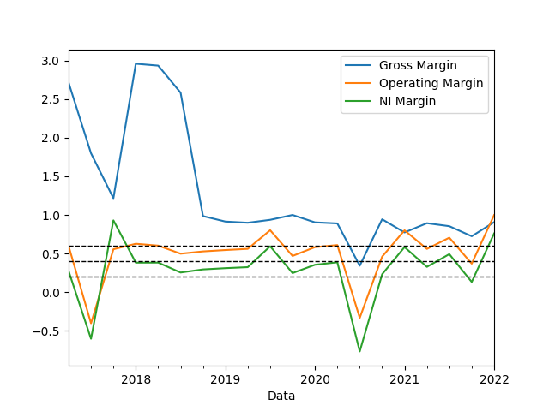

## CFO Margins

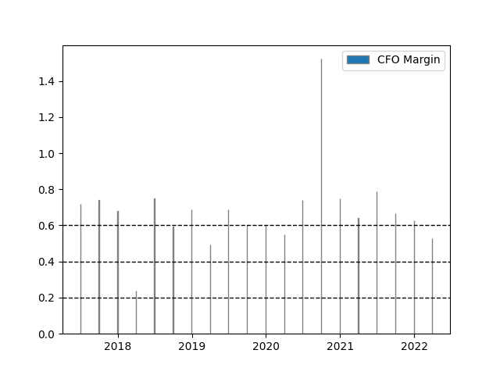

## ROA e ROE

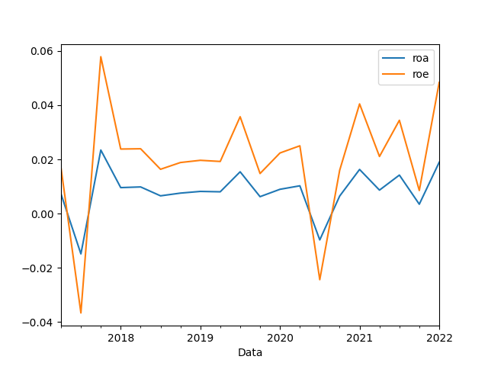

## Coverage Ratios

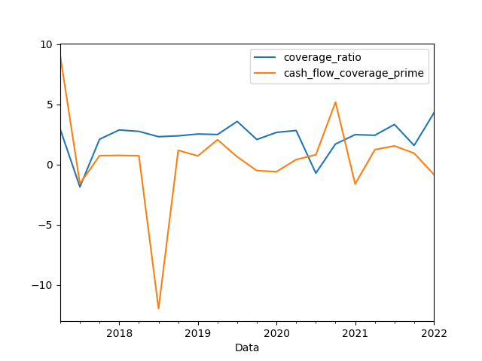

# 5. Modelos de Valorização (Resultados)

## Cash Flow Models

|  |  |  |  |  |
| --- | --- | --- | --- | --- |
| Method Valuation/Cost of Cap. | Market 3 Moment | Carhart 4 Factor | Industry F&F | **Mean** |
| Perpetuity FCF | 15.35 | 3.74 | 9.91 | 9.67 |
| Perpetuity FCFE | 44.55 | 27.81 | 36.3 | 36.22 |
| Perpetuity DDM | 32.02 | 20.29 | 26.23 | 26.18 |
| **Final Mean** | | | | 24.02 |

## Peer Valuation

|  |  |  |
| --- | --- | --- |
| Method Peer Valuation | Valuation Peer | Ind. Growth Rate (from: PEG) |
| P/S | 31.0 | -1.51 |
| P/B | 21.0 |
| P/E | 15.07 |
| P/CFO | 26.0 |
| P/FCF | 15.0 |
| Mean | 21.61 |

## Monte Carlo Simulations

* 1. Monte Carlo DDM 3 Moment
  2. Monte Carlo DDM Carhart
  3. Monte Carlo DDM Industry F&F

# 6. Prémios de Risco

## Resultados CAPM 3 Moment

|  |  |
| --- | --- |
| **Último Beta (1Y)** | 1.51 |
| **Média Beta (1Y)** | 0.92 |
| **Desvio Padrão Beta (1Y)** | 0.39 |
| **Risco Coskewness $({R_{m}}^{2})$ (1Y)** | 4.71 |
| **Risco Coskewnewss (*) (1Y)** |  |
| **Último R2** | 0.44 |
| **Último Total Beta** | 3.45 |

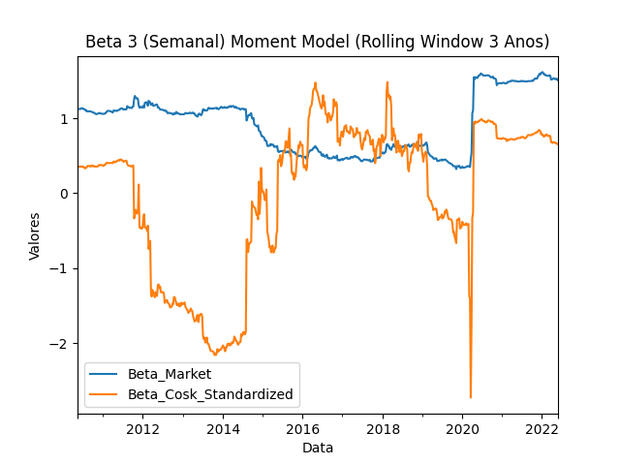

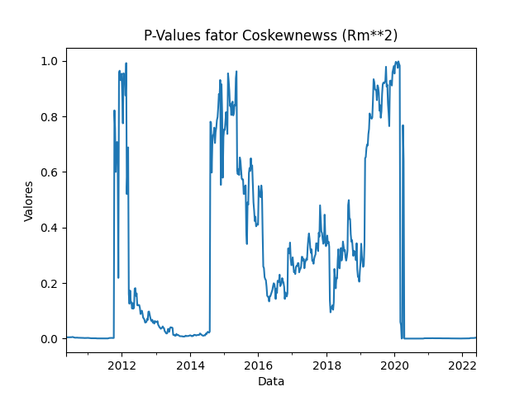

## Resultados Carhart Model (4 Factor Model)

|  |  |  |
| --- | --- | --- |
| **Factor** | **Beta** | **p-value** |
| **Market** | 1.45 | |
| **Size Factor** | 1.47 | 0.0 |
| **Value Factor** | -0.27 | 0.25 |
| **Momentum Factor** | -0.26 | 0.09 |
| **R2** | 0.57 | |

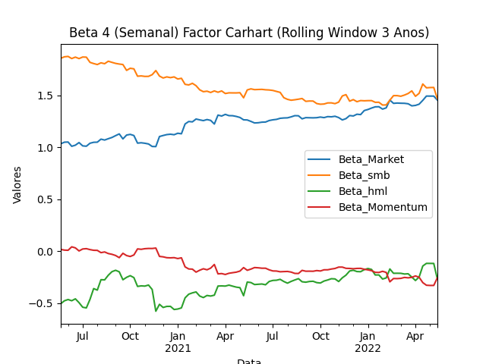

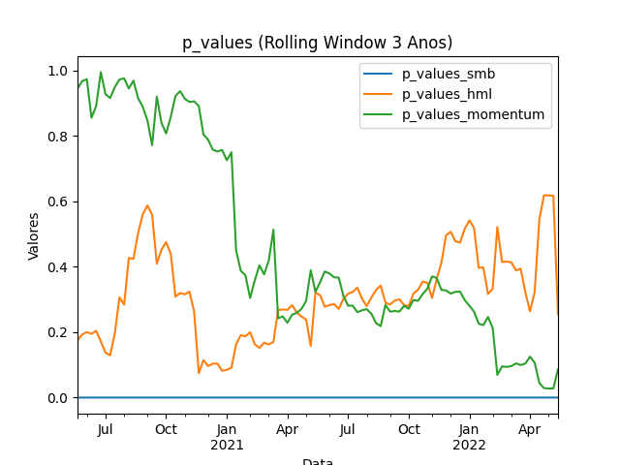

## Resultados Regressão Quantil.

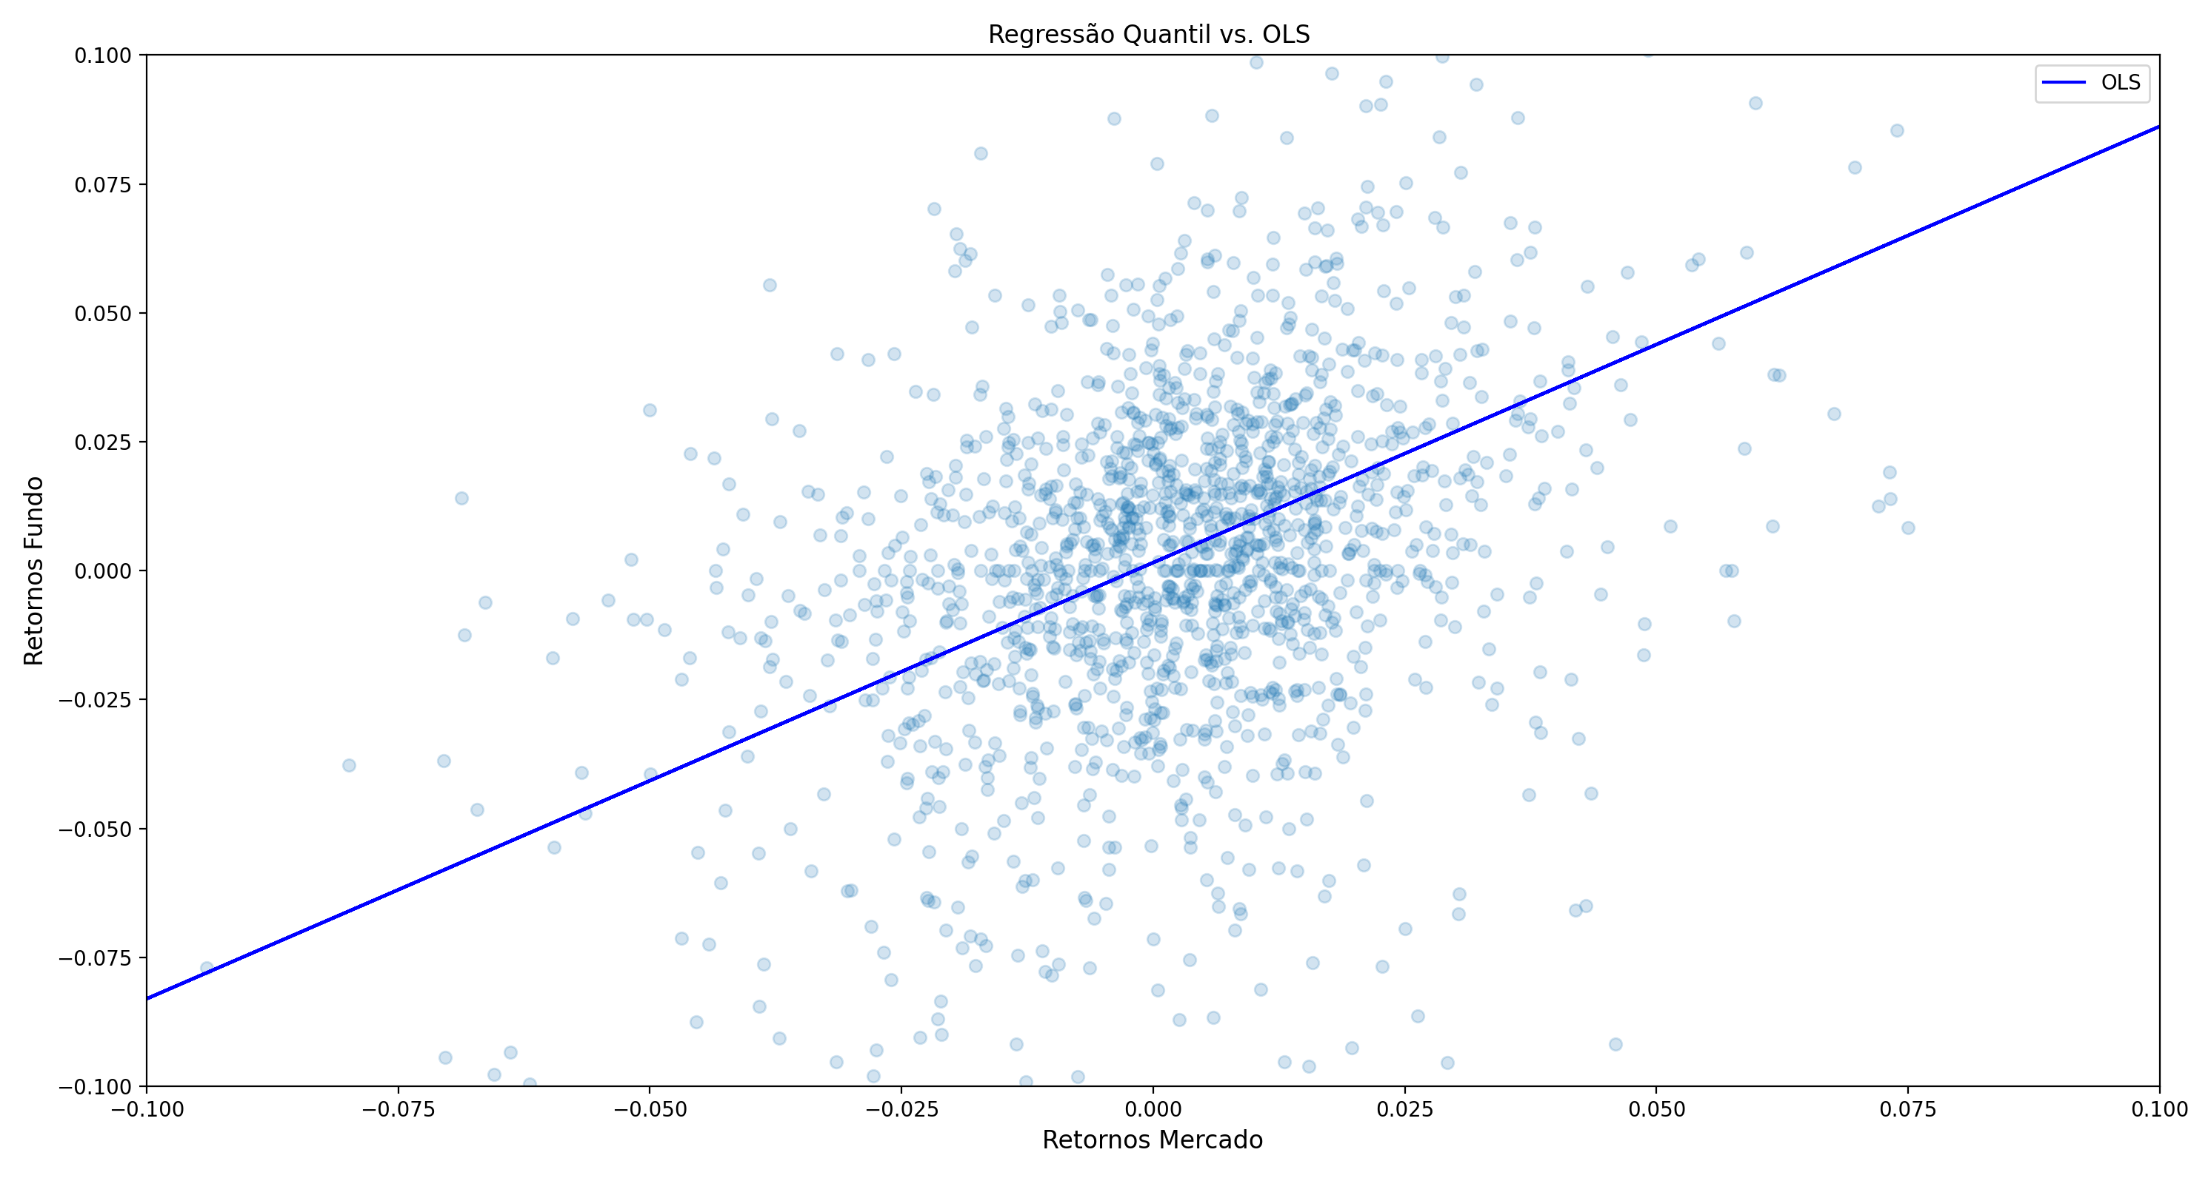

|  |  |  |  |  |
| --- | --- | --- | --- | --- |
| Quantil | Alpha | Beta Market | Lower Bound | Upper Bound |
|  |  |  |  |  |

## Models Assumption

## Model (A)

* Assumes a cost of equity of calculated using CAPM.
* Assumes cost of capital $(r)$ of calculated using WACC.
* Retrieves the FCF from Yahoo Finance API.

### A1.

* Assumes a perpetual growth $(g)$ rate of 2%.

$$Value of the Company \left(V\right)= \frac{FCF(1+g)}{r-g}$$

### A2.

* Assumes implied growth rate derived from PEG $(gs)$ for 1 year
* Assumes a perpetual growth $(gl)$ rate of 2%.

$$V= \frac{FCF*(1+gs)}{(1+r)}+\frac{\frac{FCF(1+gl)}{r-gl}}{{(1+r)}^{}}$$

### A3.

* Assume average growth rate on revenue for the last 3 years for the following 5 years $(gs)$.
* Assumes a perpetual growth $(gl)$ rate of 2%.

$$V= \sum_{i}^{n=5}{\frac{{FCF}_{0}*{(1+gs)}^{n}}{{(1+r)}^{n}}}+\frac{\frac{{FCF}_{5}(1+gl)}{r-gl}}{{(1+r)}^{n}}$$

## Model (B)

* Assumes a cost of equity of calculated using CAPM.
* Assumes cost of capital $(r)$ of calculated using WACC.
* Retrieves the FCF from Yahoo Finance API.

### B1.

* Assumes a perpetual growth $(g)$ rate of 2%.

$$Value of the Company \left(V\right)= \frac{Div(1+g)}{r-g}$$

### B2.

* H-Model is used, where H = 5 years.
* Short term growth rate $\left(gs\right)$ derived from Sustainable Growth rate (SGR) of the company.
* Long term rate $(gl)$ converges to industry SGR.

$$V_{(H-Model)}= \frac{Div*\left(1+gl\right)+Div*H*(gs-gl)}{(r-g)}$$

## Monte Carlo Simulation

* Retrieves data from Alpha Vantage API.
* Randomly generate inputs assuming a normal distribution for each input
  + 1000 Iterations
  + Sensitivity inputs:
    - Revenue growth rate
    - EBIT Margin
    - Working Capital to Revenue ratio
    - CAPEX to Revenue ratio